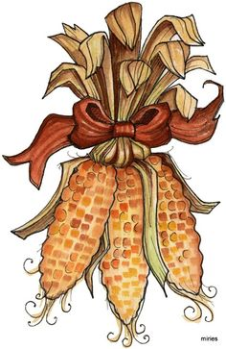

**Compare and Contrast:  
Daily Life and The First Thanksgiving**

**Name: _________________**

**The Wampanoag**

**The Pilgrims**

How were they **alike?**------------------------------------------------------------------------------------------------------------------------------------------------------------------------------------------------------------------------------------------------------------------------

How were they **different?**

------------------------------------------------------------------------------------------------------------------------------------------------------------------------------------------------------------------------------------------------------------------------

------------------------------------------------------------------------------------------------------------------------------------------------------------------------------------------------------------------------------------------------------------------------